2014 -2018 Strategic Plan

www.getcollaborative.com

Planning Process
In 2014, Foster & Adoptive Care Coalition (FACC) engaged in a strategic planning process with four stages as described below:
- Diagnostic – evaluating FACC’s current condition and environment
- Planning – establishing a shared vision for FACC’s future
- Action Planning – determining the specifics of how FACC will achieve its goals
- Commitment – committing to the plan and agreeing on a process for monitoring progress
Collaborative Strategies, Inc. facilitated the planning process and organized the 11-person planning team listed below:
Marcia Ambrose | John Phillips
Jane Dueker | Marty Stammer
Debbie Genung | Melanie Scheetz
Denise Kelley | Nickie Steinhoff
Laura Lueken | Rossi Summers
Maren Mellem | Shelley Thomas-Benke

Collaborative Strategies facilitated an extensive diagnostic analysis that grounded the strategic plan in the reality of FACC’s current situation. Quantitative analysis covered FACC’s outcomes, program participation trends, financials, and philanthropic results. Qualitatively, CSI conducted numerous interviews with staff, community partners and funders.
The planning team held two extended meetings to review diagnostic findings and create the overarching planning deliverables – mission, vision and strategic priorities. Then small groups met to drill deeper into action plans to support each strategic priority.

Planning Deliverables

Mission & Overarching Vision
“Mission” describes our enduring purpose. It explains why we exist. The planning team affirmed FACC’s existing mission, though they suggested a minor wording change to “St. Louis region”:
The Foster & Adoptive Care Coalition strives to create permanency in every foster child’s life by recruiting and supporting foster and adoptive families in the St. Louis region.
FACC’s last strategic plan was mostly internally focused on building organizational capacity. This year, the planning team was inspired to make its plan more externally focused, leveraging FACC’s capabilities to make a transformative difference on the foster care system in the St. Louis region. Working both directly with foster/adoptive families and through coalition partners, FACC is on the cusp of launching exciting, innovative approaches to recruiting and supporting foster/adoptive families.

2018 Goals
To create focus for our planning efforts, the team developed a series of goals that the Coalition should accomplish in the next four years. In aggregate, these goals form a concrete picture of “success” for FACC that is shared by board and staff leadership.
Outcomes
- We can prove economic savings from implementing our 30 Days to Family program for state and federal funders.
- We’ve doubled the number of kids served with 30DF over the 2014 baseline.
- We train approximately the same number of professional staff as we did in 2014. Steady training work has allowed us to focus on program fidelity and evaluation of our signature programs.
- 70%+ of families referred for licensure follow through to become foster parents.
- Though we may occasionally work outside St. Louis, our mission remains focused on our region.
- The region has adopted a standardized home study.
- Focusing on quality, not quantity, our “direct clients” have grown modestly (<5% per year) since 2014.

Programs & Services
- We have developed an innovative (and more comprehensive) approach to pre-service training that follows families through placement (“concierge model”), provides a greater supply of foster-adoptive parents, and improves the chances for successful placements.
- We were instrumental in STL establishing a regional training center for prospective foster parents.
- With our expanded training of professionals we lever our ability to improve the experiences of foster-adoptive children and families.
- The outcomes study for 30 Days to Family has been successfully completed, proving its positive impact. Our recruiting programs are being replicated throughout the region and beyond.

Capacity
- Overall staff retention is at or near 90%.
- We are comfortable that workloads, while challenging, are reasonable given our mission.
- As we grow, we don’t let administrative tasks get in the way of maintaining our values and culture.
- The board has grown in size, influence and expertise. We have ample supply of members with fundraising, PR and advocacy skills.
- The board follows a documented, ongoing succession process for its leadership roles.
- We continue to provide meaningful work for our volunteers.
- We excel at volunteer recognition, promoting the retention of our committed team.
- In St. Louis’ best philanthropic circles, FACC is a known and admired brand.
- Continued community outreach cultivates strong relationships with policy-makers and influencers.

Financials
- We have 100+ major individual donors ($1,000+).
- Retention of major individual donors exceeds 75%.
- Corporate giving exceeds $100,000.
- Our unrestricted reserves total 15% of the annual operating budget.
- [REFRESH] nets $100,000+ annually.
- Out of town training generates surplus resources that advance our local recruiting and support programs.

Strategic Priorities
To begin working towards its goals, FACC must adopt a new set of priorities. “Priorities” implies focus – so there can only be a handful of true “priorities.” The planning team selected the following five areas:
- Expand our support of foster-adoptive parents to address critical gaps in the foster-adoptive continuum (see graphic for details).
- Expand our training portfolio for professionals as a way to lever our impact and promoting higher quality experience for foster-adoptive families (see graphic for details).
- Create heightened focus on significantly growing our major individual and corporate donor ranks. Dedicate staff and board resources accordingly.
- Invest board and staff resources in improving our brand awareness among important programmatic and philanthropic community circles.
- Take the board nominating process to “the next level”, growing our pipeline of high-impact, well-connected volunteers (including board) willing and able to advance our programmatic and capacity goals.
The planning team selected these priorities because they represent the most important changes necessary for FACC to achieve its picture of a desired future. The priorities do not represent the totality of what FACC will be doing in 2018. Many important initiatives not mentioned explicitly in the priorities are expected to continue.
The graphic on the next page illustrates the Coalition’s future program portfolio after implementing priorities 1 and 2.

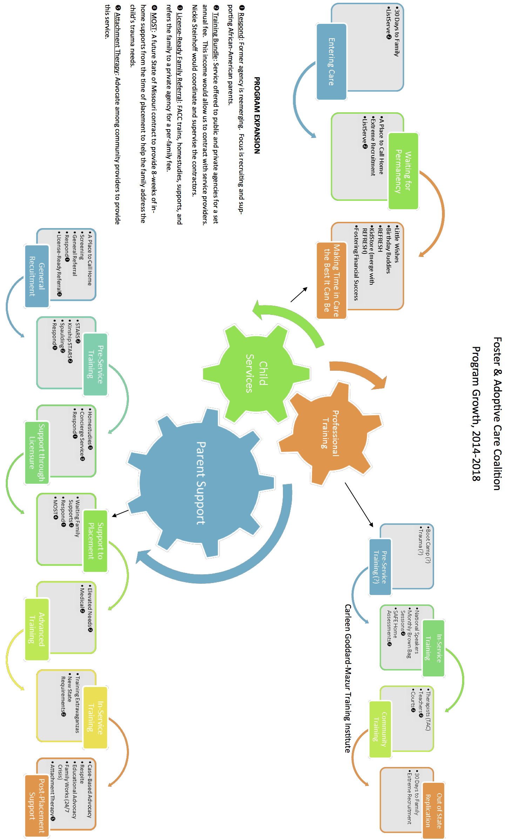

Action Plans
Each of the five strategic priorities has a project plan outlining the required tasks, timelines, and responsible parties. FACC’s leadership will regularly review progress against these action plans and make adjustments as appropriate.

Support Expansion Plan

STATEMENT OF ACTION, OPPORTUNITY OR INITIATIVE:
Expand our support of foster-adoptive parents to address critical gaps in the foster-adoptive continuum (see page 4 graphic).

ACTIVITIES: | BY WHEN? |  | WHO?
- Begin in-service training for families on new state requirements. | January 2015 |  | Nickie
- Formalize/Package our training & support offering for child-placing agencies (for their families). Elements of this training/support are likely to include coordination prior to training, delivery of pre-service training, advocacy, 1:1 support to ensure families meet their benchmarks for licensure, etc. The training/support would end at placement. | May 2015 |  | Melanie
- Evaluate and finalize our pricing strategy for these training services. One approach would be setting a fixed fee. Another approach would be performance-based, charging agencies a higher amount later, once the families are licensed. | May 2015 |  | Melanie
- Approach contracted agency about ‘outsourcing’ their family training to FACC. | May 2015 |  | Melanie
- Begin offering Elevated Needs training to increase the supply of families prepared for an elevated needs placement. | June 2015 |  | Nickie
- Append Spaulding training to our STARS training for adoptive families. | June 2015 |  | Nickie
- Pilot a program to train families at our expense, and then match them with a child-placing agency that has a waiting child (for a premium cost, since we carried the risk). |  | October 2015 | Denise
- Approach Partners about ‘outsourcing’ their family training to FACC. |  | 1H2016 | Melanie
- Assuming the MOST contract is economically viable, become a MOST support provider. |  | 2016 | Melanie
- Launch (with a partner) supportive services for families struggling with developmental trauma. |  | 2017 | Melanie
- Finalize a partnership with Respond, helping bring their ‘concierge’-type service to the community. |  | 2018 | Melanie

EXPECTED INVESTMENT REQUIRED (big ticket items/staff additions)
Description | FY15 | FY16 | FY17 | FY18
Additional staffing (covered by contracts/grants) | X | X | X | X

TARGETS AND/OR GOALS:

- 70%+ of families inquiring about licensure follow through to become foster parents.
- We have developed an innovative (and more comprehensive) approach to pre-service training that follows families through placement (“concierge model”), provides a greater supply of foster-adoptive parents, and improves the chances for successful placement.

Training Expansion Plan

STATEMENT OF ACTION, OPPORTUNITY OR INITIATIVE:
Expand our training portfolio for professionals as a way levering our impact and promoting higher quality experience for foster-adoptive families (see page 4 graphic).

ACTIVITIES: | BY WHEN? | WHO?
- Bring in Consortium for Children to train our staff and the staffs of other agencies on SAFE Home Assessments. | January 2015 | Nickie
- Coordinate an annual schedule of Monthly Brown Bag Sessions for child welfare professionals (include court professionals). | Begin monthly sessions January 2015 | Nickie
- Establish a professional development module for teachers, educating them about foster/adoptive issues. Slot the training into regularly scheduled professional development days for the school districts. | 2016 | Trish
- Re-evaluate whether there is a market opportunity to offer “boot camp” training for new child welfare professionals. | 2016 | Melanie
- Partner with CASE to bring “Training for Adoption Competency” to St. Louis for front-line child welfare staff. (FACC would be a ‘coaching site’.) | 2016 | Nickie

EXPECTED INVESTMENT REQUIRED (big ticket items/staff additions)
Description | FY15 | FY16 | FY17 | FY18
N/A

TARGETS AND/OR GOALS:

- We train approximately the same number of providers as 2014. Steady training work has allowed us to focus on program fidelity and evaluation of our signature programs.
- We were instrumental in STL establishing a regional training center for prospective foster parents.
- With our expanded training of professionals we lever our ability to improve the experiences of foster-adoptive children and families.

Fundraising Plan
STATEMENT OF ACTION, OPPORTUNITY OR INITIATIVE:
Create heightened focus on significantly growing our major individual and corporate donor ranks. Dedicate staff and board resources accordingly.

ACTIVITIES: | BY WHEN? | WHO?
Individual Giving
- Hire a major gifts staff person (“Director of Donor  Relations”). | January 2015 | Melanie
- Brand our monthly lunches/breakfasts. | January 2015 | Maren
- Start developing individual giving plans for all $250+ donors.  - Share the portfolio assignments with the board so they can facilitate relationship development.  - Train the board on how they can be involved in growing our major donors, i.e. by participating in donor cultivation meetings/stewardship. | March 2015  June 2015 | Director of Donor Relations
- Implement updated fundraising technology to ensure we have the tools necessary to track our donor interactions and interests.  - Train staff on how to best use the new technology. | June 2015 | Denise P.
- Begin harvesting candidates from board members to invite to monthly open houses/lunches (especially those who have been event guests).  - On a related note – evaluate participants in the monthly lunches as prospective committee volunteers (and eventually prospective board members) | June 2015 | Director of Donor Relations
- Re-evaluate our giving societies as tools for improving donor recognition. How can we make these societies more interesting/compelling for prospective donors? | August 2015 | Debbie
Corporate Giving
- Create a philanthropic follow-up process for corporate groups that volunteer at REFRESH (and our other programs). | February 2015 | Shelley
- Identify top corporate prospects based on their giving areas and practices. Also consider where our volunteers are coming from (since companies tend to align their giving priorities with their employees’ interests). | April 2015 | Director of Donor Relations
- Develop ‘account plans’ for each of our corporate donors over $1000. | May 2015 | Director of Donor Relations
- Develop a more deliberate process for following up with corporate donors.  - Communicating the results of their gifts  - Asking how else we might be helpful with other philanthropic or volunteer needs. | July 2015 | Maren
- Run top corporate prospects through the board to identify existing relationships we might leverage. | September 2015 (completed by) | Debbie

EXPECTED INVESTMENT REQUIRED (big ticket items/staff additions)
Description | FY15 | FY16 | FY17 | FY18
Director of Donor Relations | X | X | X | X
Fundraising software | X
Stewardship funds (meals/entertainment) | $5,000 | $5,000 | $5,000 | $5,000

TARGETS AND/OR GOALS:

- We have 100+ major individual donors ($1,000+).
- Retention of major individual donors exceeds 75%.
- Corporate giving exceeds $100,000.

Marketing Plan

STATEMENT OF ACTION, OPPORTUNITY OR INITIATIVE:
Invest board and staff resources in improving our brand awareness among important programmatic and philanthropic community circles.

ACTIVITIES: | BY WHEN? | WHO?
- Advertising  - Investigate retaining a pro bono ad agency. (We have leads on Rodgers Townsend.)  - Develop integrated marketing/communications plan | (Start dates)  November 2014  2016 | Maren
- Relook at our branding document and revise for our latest capabilities and programs. | July 2015 | Maren
- Public relations  - Investigate retaining a PR agency. (We may have leads on Black Twig and Standing Partnership.) This relationship may be for-hire or pro bono.  - Proactively seek out speaking opportunities with relevant constituencies.  - Evaluate starting an “igniter” program. The concept is that we’d assemble a group of ambassadors with the sole purpose of spreading the word on the Coalition to their circles of influence.  - Investigate utilizing CSPRC (Community Service Public Relations Council) to find additional PR expertise. | (Start dates)  August 2015  July 2015  July 2015  2018 | Maren
- Create a social media position to push out pictures and stories of our volunteer experiences. This will start as an internship. (The Coalition will need a person to manage this resource.) | September 2015 | Shelley
- Public affairs  - Identify our top policy priorities and top stories we want to tell.  - Create our list of high potential targets  - Match targets with FACC representatives | 2016 | Maren
- Make our website mobile-friendly. | 2016 | Denise P.

EXPECTED INVESTMENT REQUIRED (big ticket items/staff additions)
Description | FY15 | FY16 | FY17 | FY18
PR services | ? | ? | ? | ?
Advertising | ? | ? | ? | ?
Website redo |  | X
Staffing resources | X | X | X | X
Volunteer recognition | X | X | X | X

TARGETS AND/OR GOALS:

- The board has grown in size, influence and expertise. We have ample supply of members with fundraising, PR and advocacy skills.
- In St. Louis’ best philanthropic circles, FACC is a known and admired brand.
- Continued community outreach cultivates strong relationships with policy-makers and influencers.

Board Nominating Plan

STATEMENT OF ACTION, OPPORTUNITY OR INITIATIVE:
Take the board nominating process to “the next level”, growing our pipeline of high-impact, well-connected volunteers (inc. board) willing and able to advance our programmatic and capacity goals.

ACTIVITIES: | BY WHEN? | WHO?
- Establish a standing nominating/governance  committee led by the Vice President. Charge it with:  - Spurring board recruiting  - Managing board terms and our skills grid  - Running board orientation  - Creating a calendar of board training (for all board members). Cover topics such as governance, ‘perfecting our pitch’…  - Periodically reviewing bylaws | November 2014 | John
- Reinstitute the practice of having representatives from the board and junior board attend one another’s meetings. | November 2014 | Maren
- Develop the process for bringing on new volunteers/board members. Do we want volunteers to start on a committee (vs. jumping straight to the board)? | June 2015 | Nominating/ Governance Committee
- Document the board succession planning process (for all officers). | June 2015 | Nominating/ Governance Committee
- Identify target communities in STL we want to involve. Then work backwards with board members (as a group) to determine who might connect us to those communities.  - Corporate connections  - Diversity  - Stakeholders  - Circles of influence | Septembers, annually | Nominating/ Governance Committee
- Repeat our board assessment (turn into an annual process). | Distribute in October, annually | Nominating/ Governance Committee
- Hold an annual board gathering to build camaraderie and engagement. (Perhaps at a board member’s home.) | Novembers, annually starting in 2015 | Nominating/ Governance Committee
- Periodically check in with community influencers who might know prospective board members (e.g. heads of the United Way, Jewish Federation, RBC, Entrepreneurs Organization (EO), our funding partners, etc.) | ongoing | Nominating/ Governance Committee & Melanie

EXPECTED INVESTMENT REQUIRED (big ticket items/staff additions)
Description | FY15 | FY16 | FY17 | FY18
Board development / social | $2,500 | $2,500 | $2,500 | $2,500

TARGETS AND/OR GOALS:

- The board has grown in size, influence and expertise. We have ample supply of members with fundraising, PR and advocacy skills.
- The board follows a documented, ongoing succession process for its leadership roles.
- We continue to provide meaningful work for our volunteers.
- We excel at volunteer recognition, promoting the retention of our committed team.

